**Mild to Moderate evaluation**

Sample_ID: **XPUDTG (CAT)**

Link: [https://release.animalbiome.com/pet/assessment/report/5e7d95c0-5976-468b-aace-2ce998110dc0](XPUDTG_.docx)

Mild to Moderate

Cats and dogs:

Any Two

(High Yellow Flag Megamonas OR (failed)

High Yellow Flag Sutterella OR (failed)

High Yellow Flag Collinsella OR (failed)

Low Yellow Flag Bacteroides OR (**passed**)

Low Yellow Flag Blautia (failed)

)

OR

Cats: 8-10 Yellow Flags: 5 (failed)

OR 5-8 Red Flags: 7 (**passed**)

OR diet recommendation of increase fiber (**passed**)

OR diet recommendation of increase protein (**passed**)

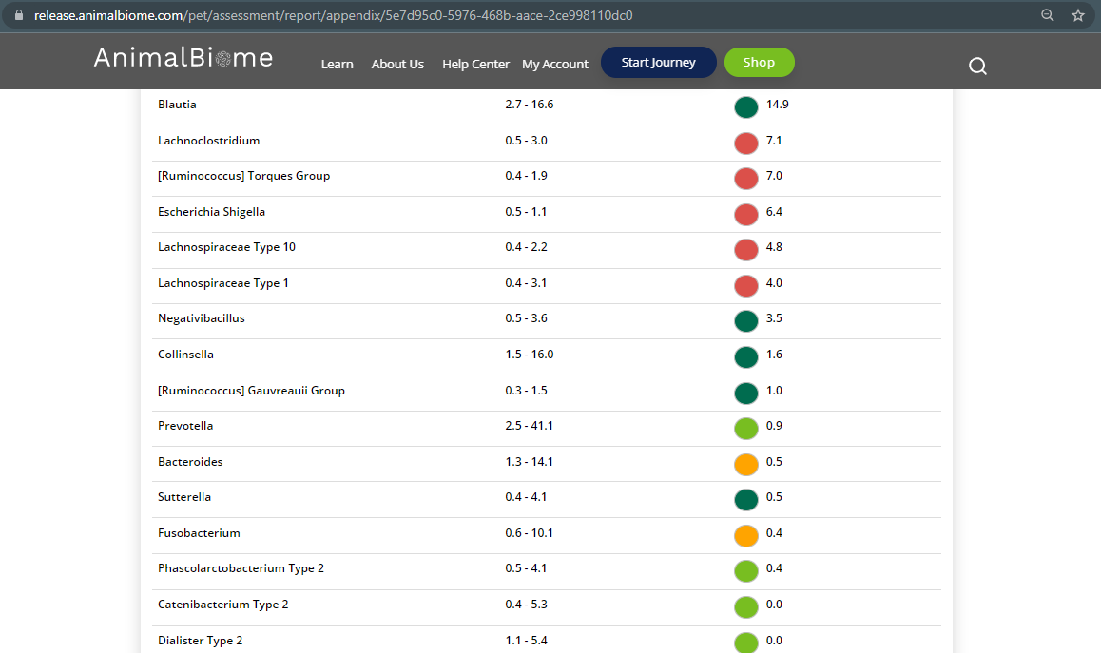

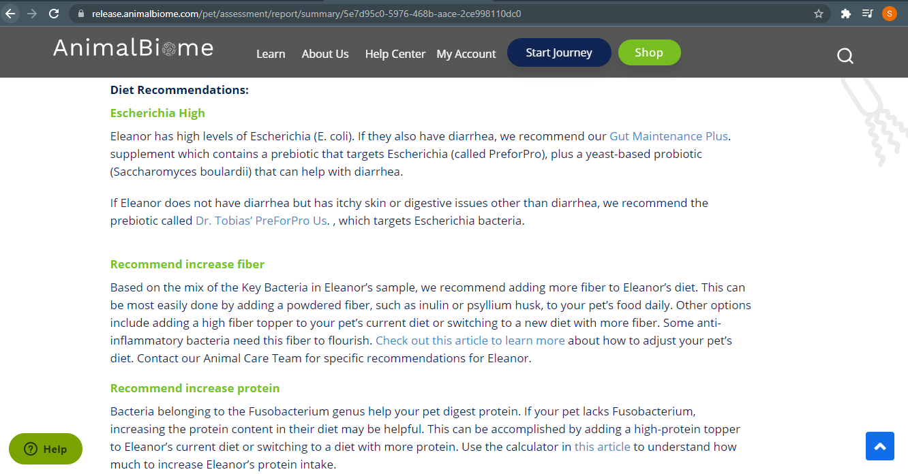

The result: **False False True True**

Expected result: Mild to Moderate

Achieved result: passed

